**Lab No 10**

**Name : Muhammad Faizan Reg. No. : 21-NTU-CS-1258**

**(Q1)**

#include<iostream>

using namespace std;

void input(int arr[3][3])

{

cout<<"Enter Array "<<endl;

for(int row=0;row<3;row++)

{

for(int col=0;col<3;col++)

cin>>arr[row][col];

}

}

void output(int arr[3][3])

{

cout<<"Entered Array is "<<endl;

for(int row=0;row<3;row++)

{

for(int col=0;col<3;col++)

cout<<arr[row][col]<<"\t";

}

}

int main()

{

int arr[3][3];

input(arr);

output(arr);

return 0;

}

**Output**

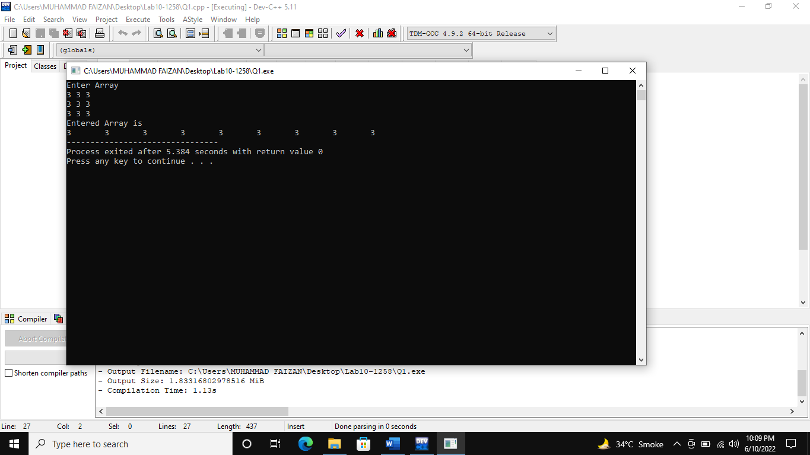

**(Q2)**

#include<iostream>

using namespace std;

int main()

{

int row,col;

cout<<"Enter Number of rows ";

cin>>row;

cout<<"Enter Number of columns ";

cin>>col;

int arr[row][col];

cout<<"Enter Array "<<endl;

for(int i=0;i<row;i++)

{

for(int j=0;j<col;j++)

cin>>arr[i][j];

}

cout<<"Entered Array is "<<endl;

for(int i=0;i<row;i++)

{

for(int j=0;j<col;j++)

{

cout<<arr[i][j]<<"\t";

}

cout<<endl;

}

}

**Output**

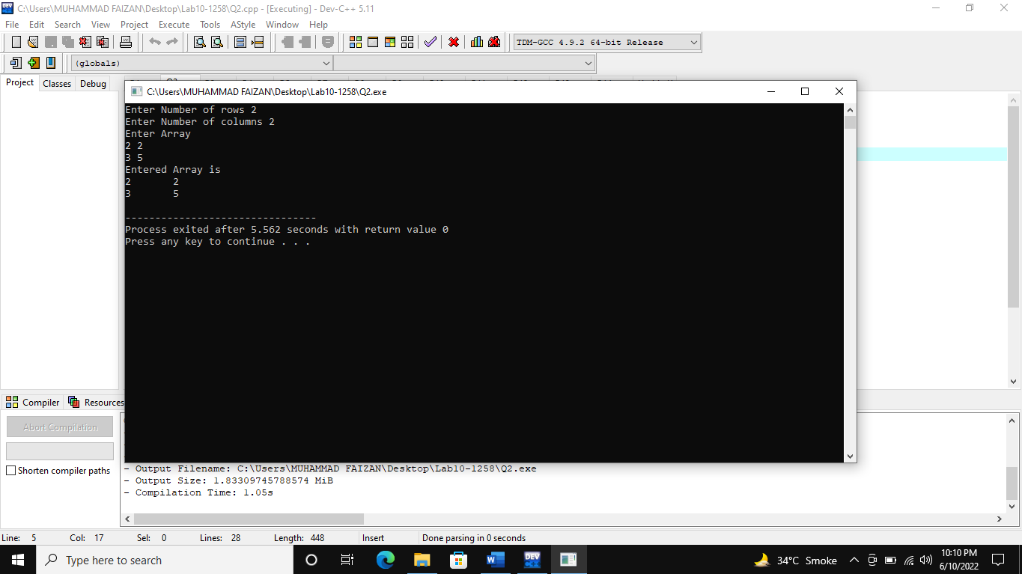

**(Q3)**

#include<iostream>

using namespace std;

int main()

{

int arr[3][3];

cout<<"Enter Array "<<endl;

for(int i=0;i<3;i++)

{

for(int j=0;j<3;j++)

cin>>arr[i][j];

}

cout<<"Entered Array is(after multiplied with 3) "<<endl;

for(int i=0;i<3;i++)

{

for(int j=0;j<3;j++)

{

cout<<arr[i][j]*3<<"\t";

}

cout<<endl;

}

}

**Output**

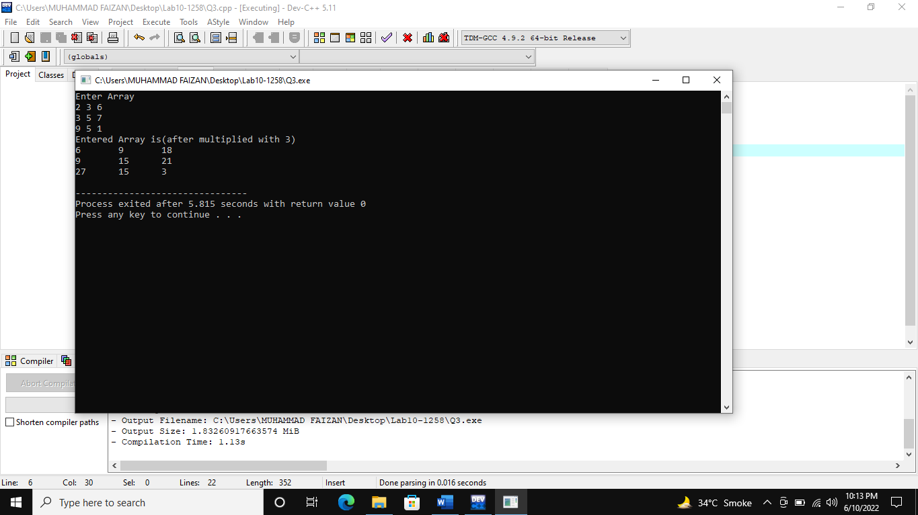

**(Q4)**

#include<iostream>

using namespace std;

int main()

{

int arr[4][5];

cout<<"Enter Array "<<endl;

for(int i=0;i<4;i++)

{

for(int j=0;j<5;j++)

cin>>arr[i][j];

}

int max,min;

max=arr[0][0];

min=arr[0][0];

for(int i=0;i<4;i++)

{

for(int j=0;j<5;j++)

{

if(arr[i][j]<min)

{

min=arr[i][j];

}

if(arr[i][j]>max)

{

max=arr[i][j];

}

}

}

cout<<"Minimum is "<<min;

cout<<"Maximum is "<<max;

}

**Output**

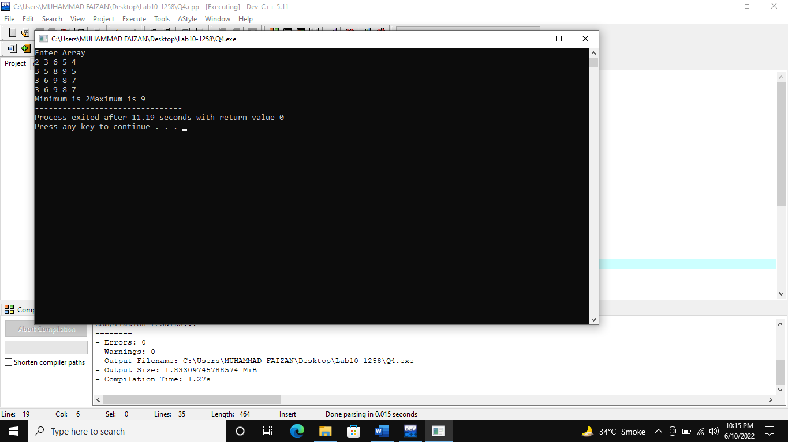

**(Q5)**

#include<iostream>

using namespace std;

int main() {

int row,col;

row=col=3;

int array1[row][col],array2[row][col],array3[row][col];

cout<<"***First array**\n"<<endl;

for(int i=0;i<row;i++){

for(int j=0;j<col;j++){

cout<<"Enter the value :";

cin>>array1[i][j];

}

}

cout<<"***\nSecond array**\n"<<endl;

for(int i=0;i<row;i++){

for(int j=0;j<col;j++){

cout<<"Enter the value :";

cin>>array2[i][j];

}

}

//multiplication

for(int i=0;i<row;i++){

for(int j=0;j<col;j++){

array3[i][j]=0;

for(int k=0;k<3;k++)

array3[i][j]=array3[i][j]+array1[k][j]*array2[i][k];

}

}

cout<<endl;

for(int i=0;i<row;i++){

for(int j=0;j<col;j++){

cout<<array3[i][j]<<"\t";

}

cout<<endl;

}

return 0;

}

**Output**

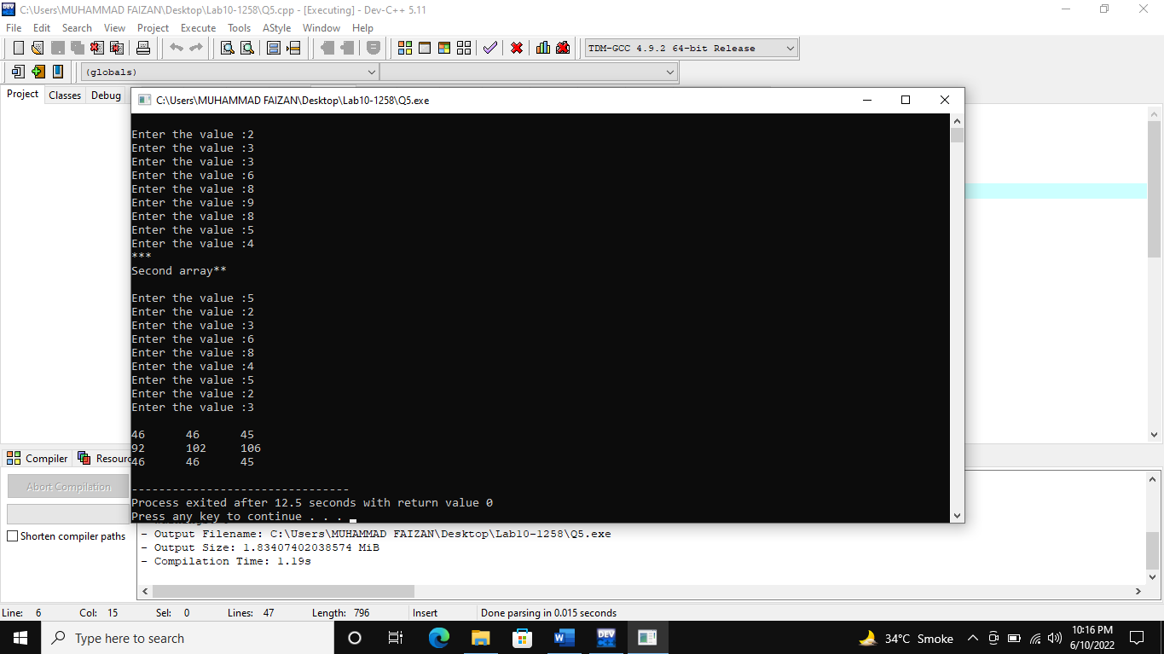

**(Q6)**

#include<iostream>

using namespace std;

int main() {

int row1,col1,row2,col2;

cout<<"***Dimension of 1st Arrray***\n "<<endl;

cout<<"Enter the numbers of row :";

cin>>row1;

cout<<"Enter the numbers of colomn :";

cin>>col1;

cout<<"***Dimension of 2nd Array***\n "<<endl;

cout<<"Enter the numbers of row :";

cin>>row2;

cout<<"Enter the numbers of colomn :";

cin>>col2;

int array1[row1][col1],array2[row2][col2];

cout<<"\n*** 1st Arrray***\n "<<endl;

for(int i=0;i<row1;i++){

for(int j=0;j<col1;j++){

cout<<i<<"*"<<j<<" enter value :";

cin>>array1[i][j];

}

}

cout<<"\n*** 2nd Arrray***\n "<<endl;

for(int i=0;i<row2;i++){

for(int j=0;j<col2;j++){

cout<<i<<"*"<<j<<" enter value :";

cin>>array2[i][j];

}

}

if ((row1==row2)&&(col1==col2)){

int sum[row1][col1],mul[row1][col2];

//sum

for(int i=0;i<row1;i++){

for(int j=0;j<col1;j++){

sum[i][j]=array1[i][j]+array2[i][j];

}

}

//mul

if(col1==row2){

int m=row2=col1;

for(int i=0;i<row1;i++){

for(int j=0;j<col2;j++){

mul[i][j]=0;

for(int k=0;k<m;k++)

mul[i][j]=mul[i][j]+array1[i][k]*array2[k][j];

}

}

//print

cout<<"\n**********Multiplication***********\n"<<endl;

for(int i=0;i<row1;i++){

for(int j=0;j<col2;j++){

cout<<mul[i][j]<<"\t";

}

cout<<endl;

}

}

//print sum

cout<<"\n**********Sum***********\n"<<endl;

for(int i=0;i<row1;i++){

for(int j=0;j<col1;j++){

cout<<sum[i][j]<<"\t";

}

cout<<endl;

}

}

return 0;

}

**Output**

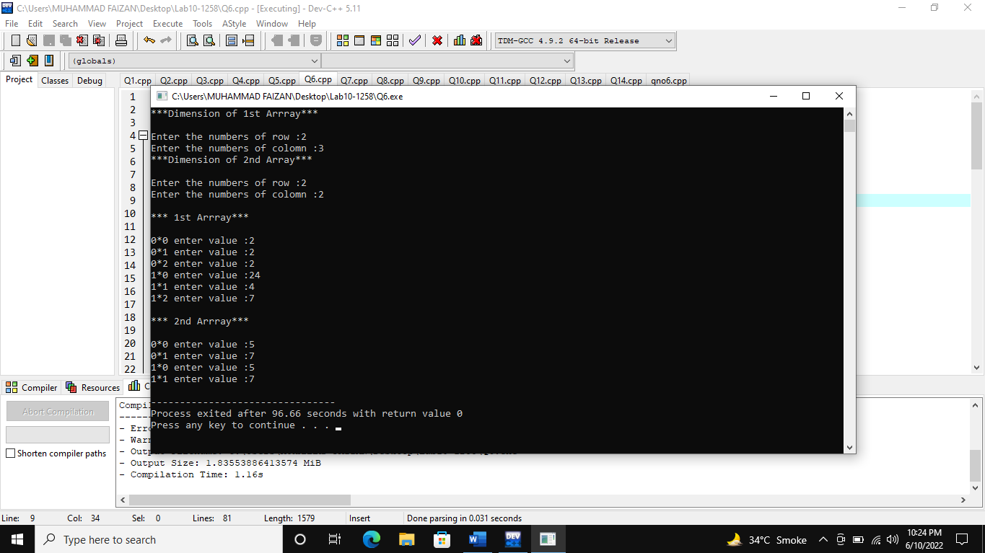

**(Q7)**

#include <iostream>

using namespace std;

int main() {

char a[3][10];

for(int i=0;i<3;i++)

cin>>a[i];

for(int i=0;i<3;i++)

cout<<a[i]<<endl;

return 0;

}

**Output**

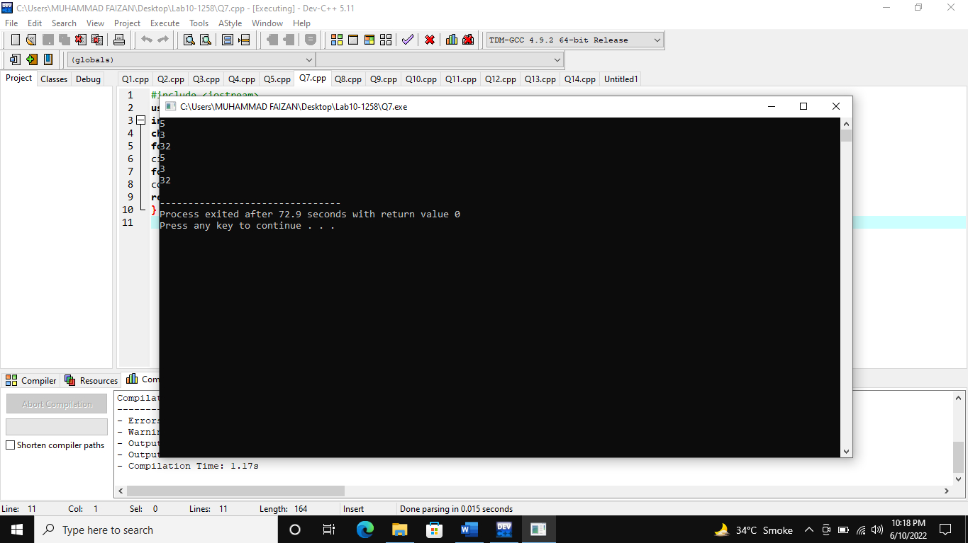

**(Q8)**

#include<iostream>

using namespace std;

int main()

{

int arr[4][6]={

{1005,75,85,80,75,(arr[0][1]+arr[0][2]+arr[0][3]+arr[0][4]/4)},

{1006,85,65,78,86,(arr[1][1]+arr[1][2]+arr[1][3]+arr[1][4]/4)},

{1007,65,70,69,58,(arr[2][1]+arr[2][2]+arr[2][3]+arr[2][4]/4)},

{1008,60,75,79,79,(arr[3][1]+arr[3][2]+arr[3][3]+arr[3][4]/4)}

};

cout<<"Student#\tProgramming\tCalculus\tLinear Algebra\tIslamic Studies\tAverage"<<endl;

for(int i=0;i<4;i++)

{

for(int j=0;j<6;j++)

{

cout<<arr[i][j]<<"\t\t";

}

cout<<endl;

}

}

**Output**

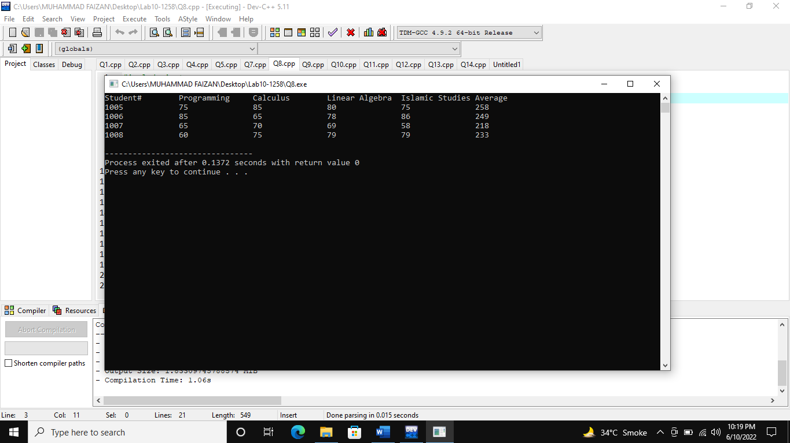

**(Q9)**

#include<iostream>

using namespace std;

int main()

{

int a=100;

char b={'a'};

cout<<"The value of integer is "<<a<<endl;

cout<<"The value of char is "<<b<<endl;

cout<<"The adress of integer is "<<&a<<endl;

cout<<"The adress of char is "<<&b<<endl;

}

**Output**

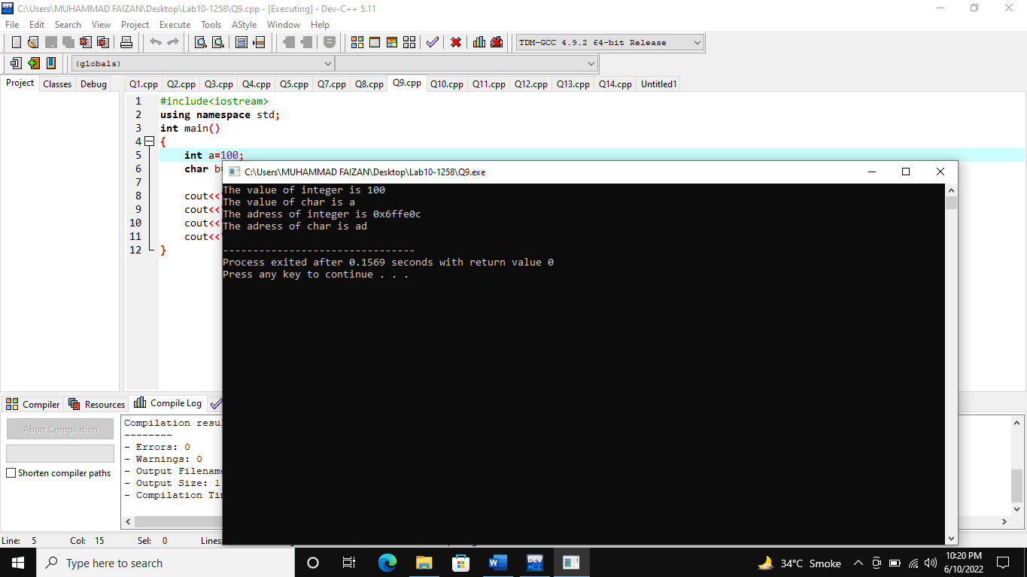

**(Q10)**

#include<iostream>

using namespace std;

int main()

{

char arr1[3]={'p','q','r'};

float arr2[3]={1.1,1.2,1.3};

cout<<"The adress of character 1 is "<<&arr1[0]<<endl;

cout<<"The adress of character 2 is "<<&arr1[1]<<endl;

cout<<"The adress of character 3 is "<<&arr1[2]<<endl;

cout<<"The adress of float 1 is "<<&arr2[1]<<endl;

cout<<"The adress of float 2 is "<<&arr2[2]<<endl;

cout<<"The adress of float 3 is "<<&arr2[3]<<endl;

}

**Output**

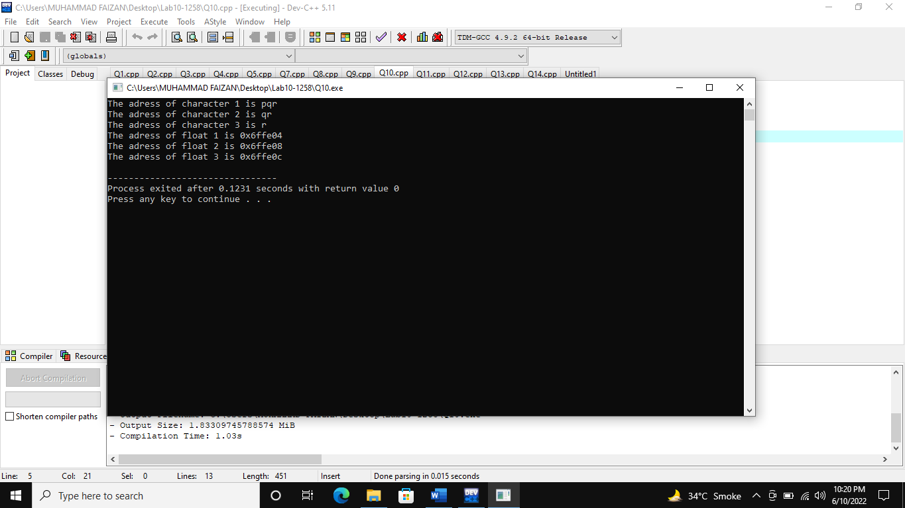

**(Q11)**

#include<iostream>

using namespace std;

int main()

{

char x,y,z;

char *p1,*p2,*p3;

p1=&x;

p2=&y;

p3=&z;

cout<<"Enter Three Characters "<<endl;

cin>>*p1>>*p2>>*p3;

cout<<"First character is "<<p1<<endl;

cout<<"Second character is "<<p2<<endl;

cout<<"Third character is "<<p3<<endl;

}

**Output**

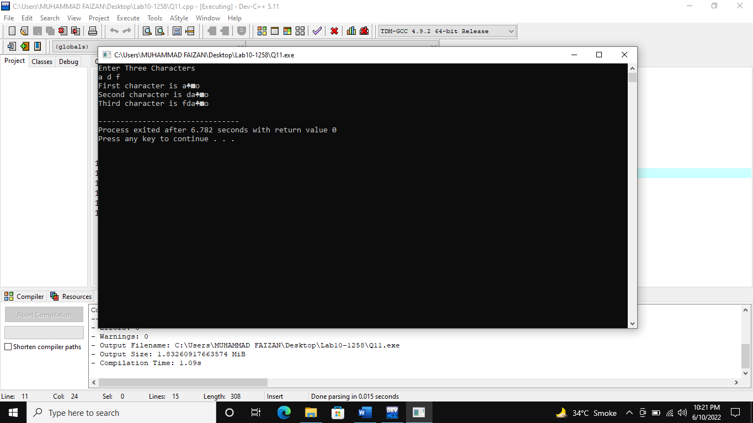

**(Q12)**

#include<iostream>

using namespace std;

int main()

{

float a,b,c;

float *p1,*p2,*p3;

float sum,avg;

p1=&a;

p2=&b;

p3=&c;

cout<<"Enter Three Numbers "<<endl;

cin>>*p1>>*p2>>*p3;

cout<<"First Number is "<<*p1<<endl;

cout<<"Second Number is "<<*p2<<endl;

cout<<"Third Number is "<<*p3<<endl;

sum=*p1+*p2+*p3;

avg=sum/3;

cout<<"Average is "<<avg;

}

**Output**

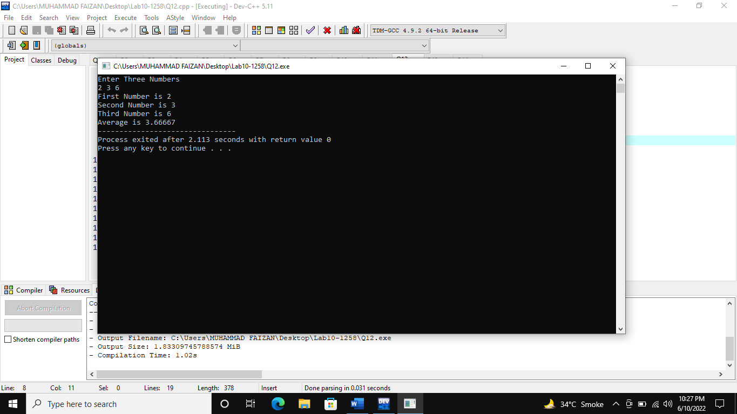

**(Q13)**

#include<iostream>

using namespace std;

int add(int *a,int *b,int *c)

{

int add;

add=*a+*b+*c;

return add;

}

int main()

{

int a,b,c;

a=1;

b=2;

c=3;

int *p1,*p2,*p3;

p1=&a;

p2=&b;

p3=&c;

cout<<"Addition is "<<add(p1,p2,p3);

return 0;

}

**Output**

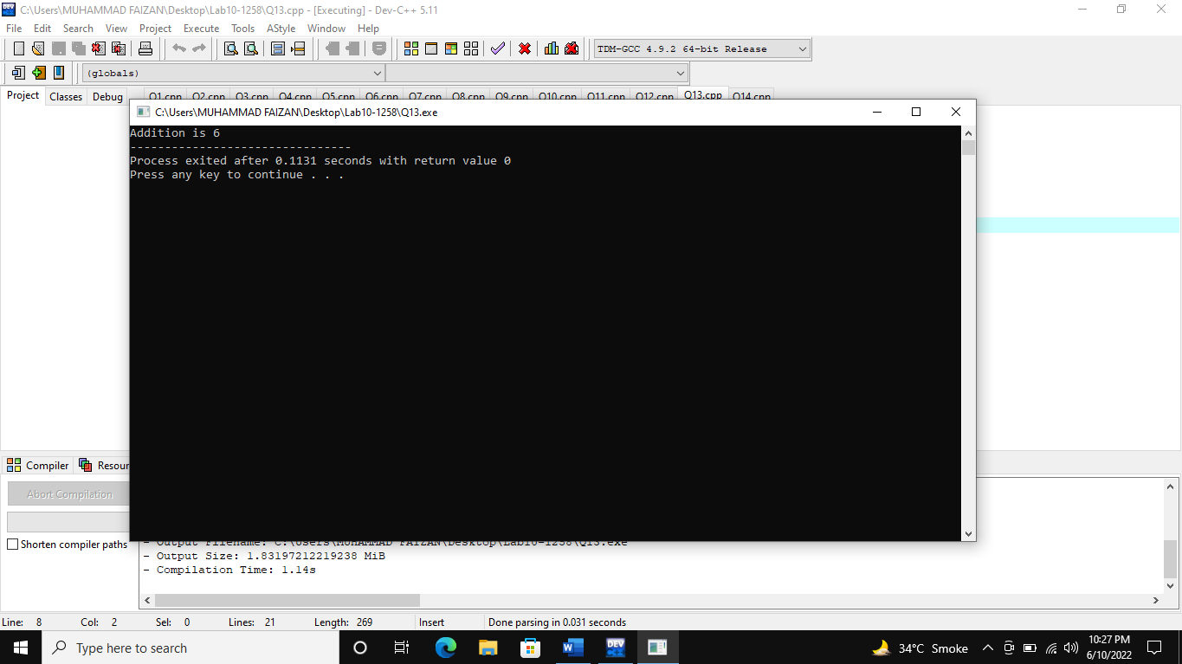

**(Q14)**

#include<iostream>

using namespace std;

void increment(int *a,int *b)

{

if(*a>*b)

{

int temp=*a;

*a=*b;

*b=temp;

}

}

void decrement(int *a,int *b)

{

if(*a<*b)

{

int temp=*a;

*a=*b;

*b=temp;

}

}

int main()

{

int size;

cout<<"Enter the size of the array : ";

cin>>size;

int array[size];

for(int i=0; i<size; i++)

{

cout<<"Enter a number : ";

cin>>array[i];

}

cout<<"\n===============================\n";

for(int i=0; i<size; i++)

{

cout<<array[i]<<"\t";

}

int *p[size];

for(int i=0;i<size;i++)

{

p[i]=&array[i];

}

for(int i=0; i<size-1; i++)

{

for(int j=0; j<size-1; j++)

{

increment(p[j],p[j+1]);

}

}

cout<<"\n=============================================\n";

cout<<"-------Increment---------"<<endl;

for(int i=0; i<size; i++)

{

cout<<*p[i]<<"\t";

}

for(int i=0; i<size-1; i++)

{

for(int j=0; j<size-1; j++)

{

decrement(p[j],p[j+1]);

}

}

cout<<"\n=============================================\n";

cout<<"-------decrement---------"<<endl;

for(int i=0; i<size; i++)

{

cout<<array[i]<<"\t";

}

}

**Output**

